Module 4, opdracht 3. Kunstkritiek

Aanvullende instructie:

Vertaal één van de volgende teksten.

The Art of Sensation (De kunst van sensatie)

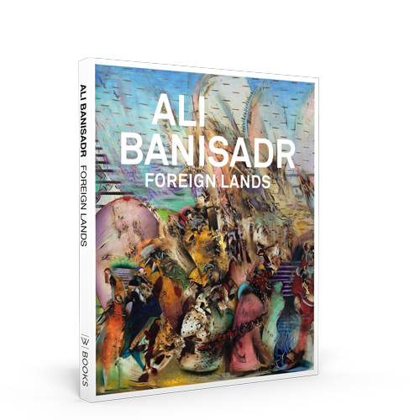

Since Ali Banisadr innovated his distinctive approach to painting in 2006, he has generously furnished art writers with names of old and modern masters whose works have had an impact on his art. When studying paintings by some of these old masters, Banisadr has discerned elements in them that foreshadow twentieth-century works of art: he has found, for example, that Hieronymous Bosch’s strange hybrids anticipate Salvador Dalí’s Surrealism, and Diego Velasquez’s signal and summary brushwork antedates Willem de Kooning’s gestural style. This process of reversing history so that agency is lodged in the predicative sovereignty of old master paintings rather than in the usual practice of modern and postmodern artists’ redirecting established modes of working to achieve distinctly new ends has had an effect on even the most perceptive critical and art historical writing on Banisadr’s art. Consequently, discussions of his connections with past works have at times overshadowed recognition of his substantial contribution to contemporary painting. For this reason, I will look at how his often proclaimed, yet rarely analyzed synesthetia has enabled him to focus on energy and rhythm as crucially important aspects of his innovative art. I consider synesthesia to constitute inter-sense modalities and thus intensified sensations.

In undertaking this analysis, I will rely on several theories advanced by French philosopher Gilles Deleuze in his 1981 monograph on British painter Francis Bacon, subtitled The Logic of Sensation, as diagnostics for investigating and placing in relief Banisadr’s contributions. This book is Deleuze’s first work after his collaborations with the Lancanian trained psychiatrist Félix Guattari, and it not only inaugurates his last period when he focused primarily on aesthetic issues, but it also remains one of his most important texts on this topic. Deleuze views sensation, which can be regarded as equivalent to Banisadr’s energy, as replacing traditional definitions of artistic form, and he considers it to be fundamental in its effects on the human nervous system, since it comes before attributions of meaning. Viewed in this way, sensation is preeminently empirical rather than rational. Deleuze’s sensation also pertains to intensities, another key term. Intensities are fundamental ontological affects, and they are predicated on both qualitative and quantitative differences, involving dynamism and transformability, even though they do not alter substances’ basic make up. They can be separated from substances by analogizing them in terms of changing weather conditions that differ from the comparative stability of their climatic zones, and they can also be appreciated as ongoing forces, such as hovering energy, heightening or diminishing humidity, changing temperatures, increases or decreases in barometric pressure, etc. In art the saturation of a given hue (a substance) and its relative value can be considered as intensities contributing to one’s sensation of it. In the realm of music one can discuss the intensity of noise and also silence, since either concentration can be loud or inaudible, depending on the differential power expended in the sustained becoming of sound or its absence. Rather than viewing intensities as stable, Deleuze regards them as always being in the process of becoming what they are perceived to be, so that intensity can be theorized as sustained dynamic forms of energy. Overall, Deleuze emphasizes sensation and intensities as aesthetic means by which art enriches humanity’s empirical, intellectual, and imaginary capabilities, and thus he views them as vital for people’s comprehension of the universe in ways that are relevant to their times. The significance Deleuze places on sensation, intensities, and also rhythm is relevant to the crucial role Banisadr attributes to energy in his art, which is realized through the generative tensions of his synesthesic combinations of sounds, forms and colors.

As extraordinarily sensitive individuals, artists often rely on so-called normal or ordinary synesthesia, a type of metaphoric thinking. However, there are a very few people like Banisadr who go experience two sensations from a single unique stimulation, thus placing him in the much smaller group of clinical synesthetes. Art historian E. H. Gombrich has compellingly described this type of synesthesia as “the splashing over of impressions from one sense modality to another.” According to Banisadr, who lived in Iran until he was 12 and experienced at close hand the devastation created by Iraq’s invasion of his country during the years 1980-1988, synesthesia became a way to make sense of these experiences. He explains, “My mom says that when the Eight Years’ War was happening, I would draw to create a visual understanding of the sounds I was hearing—the vibrations, explosions, and air raids. It was automatic.”

Bron: Hobbs R. (2019). The Art of Sensation. In: Ali Banisadr. Foreign Lands. WBooks, Zwolle, Nederland in samenwerking met Noordbrabants Museum.

In Praise of the Cure of Folly (Lof der Keisnijding)

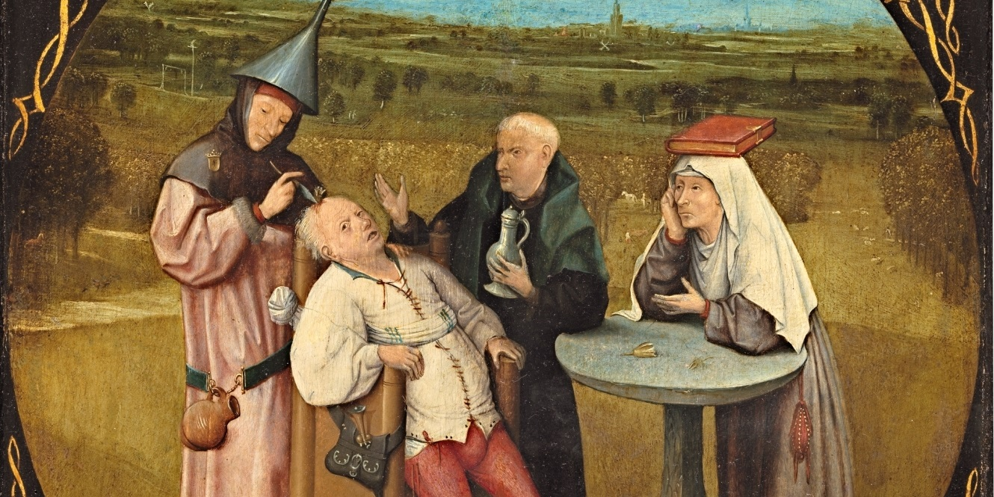

Paintings are never just paintings. They are tools through which society expresses ideas about itself. They may well be ways of escape. Left to float alone in their clouds of adjacent reality, just beyond the world we recognise, out there on their own in a state of shimmering drift, in a world of the subconscious and the imagination – in a world farfelu – where everything intersects and gets tangled up beyond time giving an illusion of being catapulted into a different world, they may challenge us not just to think about different things but to think about things in different ways. At different times they mean different things to different people. Audiences change, each new one brings something to the picture that may resonate with the viewer in a different way depending on the degree to which they share the experiences and cultural heritage of the artist. We may be unable to second-guess judgements made generations ago in different circumstances according to a harsher moral code, but certain elusive pictures may be a way to appreciate how the past is lying in wait for the present. Every generation looks for new things in the past and asks different questions. As the historian Leopold von Ranke liked to ask, “what really happened?”

The Cure of Folly, known from an early copy of an early work by Bosch presents a verbal and visual game of overlapping and contrasting meanings linked to the violent tenor of life and the spiritual climate of 16th century Brabant. It was originally painted when Bosch was around 30 years old, some time before he joined the Brotherhood of Our Lady, when he was collaborating with his brother Goeswinus on a triptych for the high altar of St John’s Church in ’s-Hertogenbosch. Saint John’s was the venue for the 14th chapter meeting of the Order of the Golden Fleece in 1481 attended by Maximilian of Austria and Engelbert II of Nassau. 36 heraldic shields had been installed in the choir to commemorate the visit just as they had been hung in every church since 1430 where this Burgundian chivalric order met. Serving as a conversation piece and an artistic fabliau the painting was both a visual reflection and a parody of these blazons. It later adorned the dining hall of the bishop’s palace at Wijk bij Duurstede.

We are looking at one of the earliest genre paintings, one that stands at the beginning of a long tradition, copied by followers of Bosch and reworked over centuries by many others, a moral message that transforms a popular saying into a visual image with accompanying text. A comment on wickedness, folly, and the incurability of idiocy, it is about tormenting the helpless. Folly is in full sway. A fraudulent quack is about to perform a charade of an operation. The credible dupe is his own victim. Set against a lush landscape of peaceful lowlands, a layered vista of green fields that recede into a delicate blue atmosphere, albeit with the gallows and a wheel on a stake clearly visible, it is clear that the man’s misfortune is of no moment to the world at large. The wages of folly are death. The inscription surrounding the image reinforces the theme, the futility of temporal healing arts as opposed to the spiritual.

There is something compelling and mysterious in its simplicity. It is very unsettling, the tormenting of a single man hundreds of years ago in which voyeurs find themselves complicit, accomplices savouring the cruelty in this demonstration of human wickedness.

Fear of deception permeated everything. Certainty was an obsession that defined Christianity in the early modern era. But nothing here is certain. What is wrong with this picture? Who and what is real? Foolish confidence and superstitious dread caused Christians to believe all manner of false stories. But is this a false story? Is Bosch taking measure of the moment, mixing the extraordinary with the mundane in his distinctive way, indirectly, with open-ended meanings and an element of mystery?

Was it perseverance or madness that brought these four people together? Only the patient looks at us. The others appear uninvolved with the impending violence. The monk appears anything but reassuring, the nun appears to gloat with pleasure and obstinate malice at what is about to occur and, despite being tied to the chair, the victim appears all too willing. The mixture of lunacy and malignancy is awful to contemplate.

Bron: Hitchins S. (2019). In Praise of the Cure of Folly (Lof der Keisnijding).

